To:
From: Jourdan Hathaway, VP of Marketing
Date: May 2020 (FY21)
Re: Jourdan Hathaway’s FY21 Professional Development Plan (i.e., Project FLAT)

Overview of Project FLAT: Financial Literacy Advancement Training
This document contains my FY21 Professional Development Plan. As a new VP, I wanted to create a roadmap containing the skills, actions, and conscious intentionality needed to further myself in career (and life) to achieve my professional goals. My aim with this plan is to consciously work on developing myself so I will advance my higher-level competencies; and subsequently, the application of them to further our organization’s goals.

Why FLAT?
There is nothing noble in being superior to your fellow man; true nobility is being superior to your former self. – Ernest Hemingway
I’ve self-identified the need to “flatten my own learning curve” so to speak – particularly focused on financial literacy and acumen. It’s also a metaphor for “leveling the playing field”, giving me the same chance of succeeding in rooms/situations where there’s an established common language and laser focus on financial matters.

Rather than change management, team leadership, or the marketing and technology disciplines, I’ve chosen to focus FY21 development on advancing my financial literacy, with the supposition that the other areas already have a proven track record of high competency.

When highly successful (non-finance) employees are promoted to positions of executive leadership, it is assumed that they suddenly understand the new rung of financial information being provided to them. That’s typically not true (The Dismal Financial IQ of US Managers, HBR.org).

What are the drivers of my Project FLAT – what are the benefits I’m seeking from this development?

Non-finance leaders, regardless of their primary domain of expertise, can significantly benefit from gaining a fundamental understanding of finance for several reasons:

- Decision Making: Financial acumen will allow me to make informed decisions that consider both the strategic and financial implications of my choices. I’ll be able to evaluate projects and initiatives not only in terms of their qualitative value but also in terms of ROI, payback period, and NPV (had to learn what the heck that means), among other financial metrics.
- Resource Allocation: As a leader, I often must decide how to best allocate resources within my teams or departments. Understanding financial concepts can help me have another lens to prioritize projects or initiatives that offer the best financial returns.
- Budgeting and Forecasting: Non-finance leaders are typically responsible for their department's budget. Understanding how to create, manage, and forecast budgets is essential to ensuring my department remains financially viable and aligned with our broader business goals.
- Communication with Finance Teams: Having a basic understanding of financial principles will enable better communication with the finance department. It will allow me to understand and justify budget requests, interpret financial reports, and actively participate in financial discussions in a more substantive way.
- Strategic Planning: Financial literacy is integral to strategic planning. With a deeper financial understanding, I could better align the department's strategies to our financial goals, ensuring congruence and maximizing my department's contribution.
- Risk Management: Financial knowledge helps in assessing the financial risks associated with various decisions. This will help with my decision-making in taking informed risks or creating strategies to mitigate potential downsides.
- Enhanced Credibility: When I upskill in this area and demonstrate a grasp of financial concepts, I’ll inherently broaden credibility. I’ll become a more well-rounded professional who understands the broader business context.
- Career Advancement: As professionals climb the corporate ladder, a broader skill set that includes financial acumen becomes increasingly important. To continue elevating, I’ll need to understand the financial health of the entire organization, even if my primary expertise lies elsewhere.
- Stakeholder Engagement: From QBRs to earnings prep, I engage with many different stakeholders. While I know the marketing numbers fluently, being conversant in finance will help in communicating the value props, project ROIs, and financial stability of projects.
- Holistic Business Understanding: I’m keenly aware that finance is the language of business. To understand our business holistically, I need to appreciate how different functions interact and contribute to the bottom line. Financial knowledge provides a lens to evaluate these interactions.

Upskilling Myself with Project FLAT (Financial Literacy Advancement Training will aid in making more effective decisions and will foster a comprehensive understanding of the business, enabling me to contribute more significantly to our overall success.
Self-Assessment
My current self-assessment of my financial literacy and acumen is that I’m at stage 2.

- Stage 1: Unconsciously Incompetent “I don’t know what I don’t know.”
- Stage 2: Consciously Incompetent “I know what I don’t know.”
- Stage 3: Consciously Competent “I grow and know and it starts to show.”
- Stage 4: Unconsciously Competent or Mastery “I simply go because of what I know.”
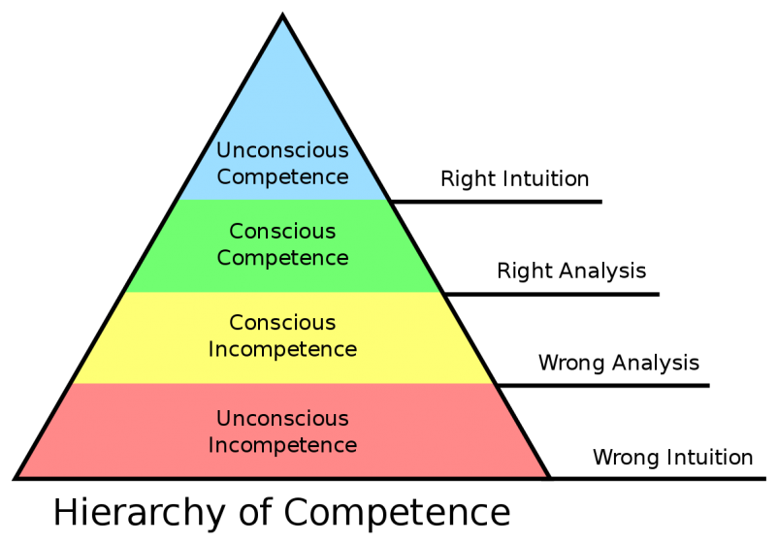
Credit: Gordon Training International, Noel Burch

My goal is not to become a finance expert, but rather to understand finance and how to incorporate a financial thinking lens into every major decision made.

Korn Ferry Leadership Architect™ Global Competency Framework (Book: FYI For Your Improvement)
Factor 1: Thought | Cluster A: Understanding the Business | Competency 17: Financial Acumen

LESS SKILLED | SKILLED | TALENTED | OVERUSED SKILL
Current State | Target State |  | Undesirable
Is unfamiliar with financial terms | Understands the meaning and implications of key financial indicators | Transforms financial information into business intelligence through analysis and integration of quantitative and qualitative information | Uses financial indicators as the only decision criteria, leading to an unbalanced view of organizational performance that is narrowly focused on financial outcomes
Is unclear about the cause and effect relationships among different business functions and overall financial performance | Uses financial analysis to generate, evaluate and act on strategic options and opportunities | Identifies and monitors key financial indicators to gauge performance, identify trends and suggest strategies that can impact results | May sacrifice long-term business objectives for short-term financial gains
Pays little attention to financial impact when drawing conclusions (or in my specific case, does not fully comprehend it beyond the student lifecycle side) | Integrates quantitative and qualitative information to draw accurate conclusions

Self-Paced, Time Bound, Development Activities

Timing | Resource | TYPE | DESTINATION
FY21 Q1 | Establish 20-minute daily finance reading ritual / habit | Prioritization | Project FLAT daily non-negotiable calendar appointment
FY21 Q1 | The Dismal Financial IQ of US Managers | Article | https://hbr.org/2009/10/us-managers-a-dismal-financial
FY21 Q1 | Financial Literacy Is Every Business's Responsibility | Article | https://www.forbes.com/sites/forbesleadershipforum/2011/07/26/financial-literacy-is-every-businesss-responsibility/#25fc0af560f3
FY21 Q1 | Understanding Accounts: Basic Finance for Non-Financial Managers | Article | https://www.mindtools.com/pages/article/newCDV_45.htm
FY21 Q1 | GSV's TalentED | Article | https://gsv.ventures/insights/
FY21 Q1 | The Chronical of Higher Education | Article | https://www.chronicle.com/
FY21 Q1 | Harvard Business Review – Finance Section | Article | https://hbr.org/topic/subject/finance-and-investing
FY21 Q1 | Wiley's bi-weekly COVID-19 Economic Impact Report | PowerPoint | Email
FY21 Q1 | 2U Investor Day | Report | PDF
FY21 Q1 | Monthly peer-to-peer finance meetings with Jack, Jeff and members of their teams | Meeting | Virtual meetings
FY21 Q1 | Corporate Finance For Dummies Paperback (Michael Taillard) | Book | https://www.wiley.com/en-us/Corporate+Finance+For+Dummies-p-9781118434789
FY21 Q2 | Financial Intelligence: A Manager's Guide to Knowing What the Numbers Really Mean [Berman, Karen, Knight, Joe, Case, John] | Book | https://www.amazon.com/Financial-Intelligence-Revised-Managers-Knowing-ebook
FY21 Q3 | Financial Literacy for Managers: Finance and Accounting for Better Decision-Making (Wharton Executive Essentials) Second Edition by Richard A. Lambert | Book | https://www.amazon.com/Financial-Literacy-Managers-Accounting-Decision-Making/dp/1613630182
FY21 Q3 | LEADING WITH FINANCE: Build an intuitive understanding of finance to better communicate with key stakeholders and grow your career.  6 Weeks, 6-7 Hrs/Week | Certificate from Harvard Business School Online | https://online.hbs.edu/courses/leading-with-finance/
FY21 Q4 | Up my game in QBR / earnings prep work group, present on business performance, seek feedback each time. Apply, repeat. | PowerPoints/memos | In Person and virtual meetings with offline orchestration

